OFFICIAL COORDINATION REQUEST FOR
NON-ROUTINE OPERATIONS AND MAINTENANCE

COORDINATION TITLE- 19BON04 Additional RT antennas for adult lamprey study
COORDINATION DATE- 25 April 2019
PROJECT- Bonneville Dam
RESPONSE DATE- 09 May 2019

Description of the problem

As part of the second year of adult Pacific lamprey dam passage studies (see attached SRWG vetted proposal) the University of Idaho would like to add up to 3 new underwater antennas into the WA shore serpentine weir section at Bonneville Dam using techniques applied in the past. The antennas would be either underwater antennas attached to weighted cables or simply surface antennas if the weighted cables are not feasible because of water velocity. The antennas would improve resolution of adult Pacific lamprey movements through the serpentine weirs, including movement through the new lamprey slots.

The primary antenna would be the one shown as the yellow dot in the figure below. Potential additional antennas may also be deployed in a similar configuration two weirs below and two weirs above the indicated location, pending field testing and in-season review of telemetry records. Figures 2 – 4 show previous deployments and the weighted cable used.

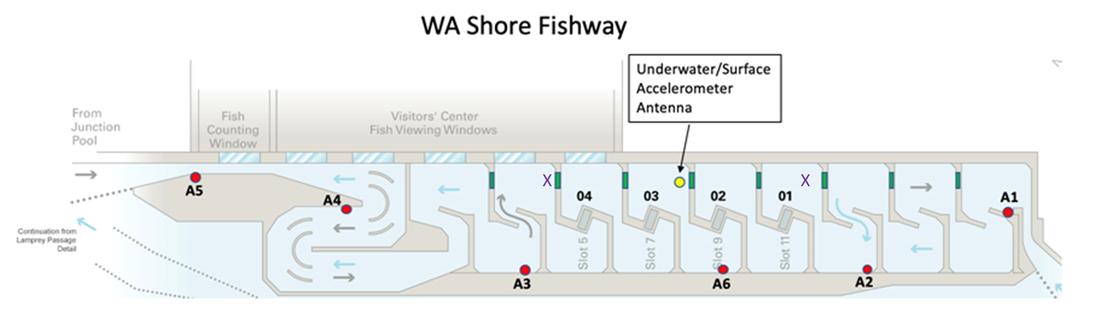

Figure 1. Proposed location of the primary radio tag antenna (depicted by a yellow circle). The two purple Xs are the two additional antenna locations being requested.

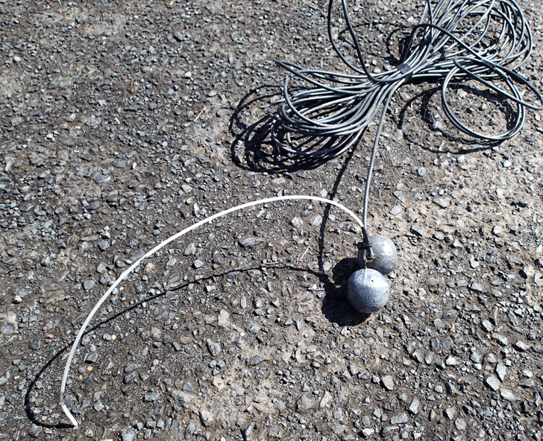
Figure 2. Coaxial cable and weight for an underwater antenna.

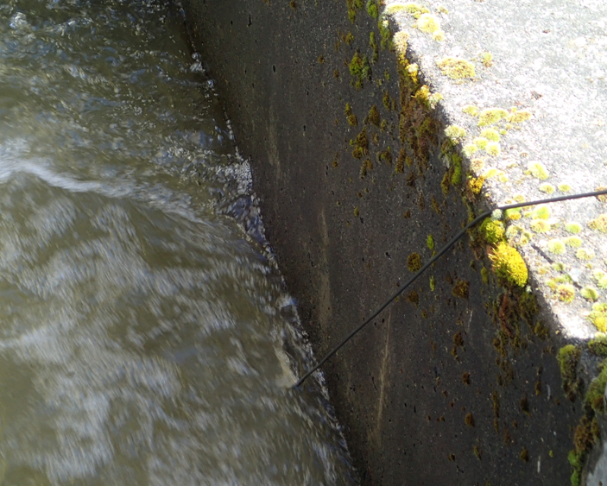
Figure 3. Deployed underwater antenna.

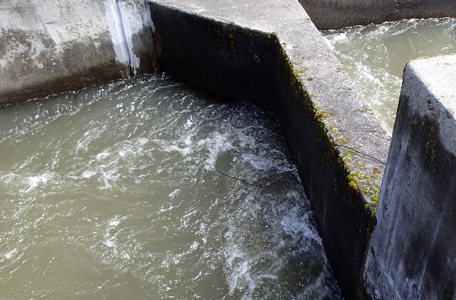
Figure 4. Deployed surface antenna.

Type of outage required - None

Impact on facility operation (FPP deviations) – Additional research equipment deployed into the fish ladder. This work is lowered into the fishway and secured above the water line. This does not require any special operations for deployment.
Impact on unit priority- None

Impact on forebay/tailwater operation - None

Impact on spill - None

Dates of impacts/repairs – May 2019 – October 2019

Length of time for repairs – 6 months
Analysis of potential impacts to fish
- 10-year average passage by run during the period of impact for adults and juvenile listed species, as appropriate for the proposed action and time of year;

This will occur during most of the fish passage season. There should be no impacts to fish passage. However, there is potential for fish to come in contact with the coax cable with very low risk of causing harm.

- Statement about the current year’s run (e.g., higher or lower than 10-year average).
Fish runs are expected to be lower than average this year.
- Estimated exposure to impact by species and age class (i.e., number or percentage of run exposed to an impact by the action).
The antennas will be in the fish ladder for most of the fish passage season and therefore fish that pass through the WA shore fish ladder may come in contact with the RT cable.
- Type of impact by species and age class (increased delay, exposure to predation, exposure to a route of higher injury/mortality rate, exposure to higher TDG, etc.).
Delay may occur as a result of fish coming in contact with RT coax and antenna.
However these impacts are unlikely and in short duration.

Summary statement - expected impacts on:

Upstream migrants (including Bull Trout)
The overall impact on Chinook and steelhead should be minimal since the RT antenna, cable, and weights are small and risk of impacts to fish is low.
The impact on bull trout would be the same as the adult salmonids; however, very few bull trout have been observed at Bonneville Dam over the last twenty years.
Downstream migrants
There are no expected impacts to steelhead kelts, juvenile salmonids, or juvenile lamprey as a result of this work.

Lamprey
Although there may be adult lamprey in the ladder, this work is expected to have minimal impact on lamprey.

Comments from agencies
PSMFC
-----Original Message-----
From: Don Warf [mailto:dlwarf@psmfc.org]
Sent: Tuesday, April 23, 2019 4:32 PM
To: Kovalchuk, Erin H CIV USARMY CENWP (US) <Erin.H.Kovalchuk@usace.army.mil>; Walker, Ricardo W CIV USARMY USACE (USA) <Ricardo.W.Walker@usace.army.mil>
Subject: [Non-DoD Source] RE: FPOM: Official Coordination 19BON04 MOC Adult Lamprey Study RT antenna install

Erin,

The radio tag antenna location is in very close proximity to the vertical slot PIT tag antennas. Has anyone looked into the possibly they could interfere?

-Don Warf
Response:
-----Original Message-----
From: Walker, Ricardo W CIV USARMY USACE (USA)
Sent: Thursday, April 25, 2019 3:40 PM
To: Don Warf <dlwarf@psmfc.org>
Cc: Kovalchuk, Erin H CIV USARMY CENWP (US) <Erin.H.Kovalchuk@usace.army.mil>; Caudill, Christopher (caudill@uidaho.edu) <caudill@uidaho.edu>
Subject: RE: FPOM: Official Coordination 19BON04 MOC Adult Lamprey Study RT antenna install (UNCLASSIFIED)

CLASSIFICATION: UNCLASSIFIED

Don,

I spoke with the U of I folks at BON today and they suggest that we test it. Is this something you and your team would be willing to do in coordination with U of I? These antennas will help us better understand how well the orifice cuts are working at WA shore and therefore worth putting a little effort in figuring out if it is feasible to install them while not interfere with PIT detections.

Thank you,

Ricardo

-----Original Message-----
From: Blubaugh, Timothy (timothyb@uidaho.edu) [mailto:timothyb@uidaho.edu]
Sent: Tuesday, April 30, 2019 5:08 PM
To: Walker, Ricardo W CIV USARMY USACE (USA) <Ricardo.W.Walker@usace.army.mil>; Don Warf <dlwarf@psmfc.org>; Brink, Grant (gbrink@uidaho.edu) <gbrink@uidaho.edu>; Caudill, Christopher (caudill@uidaho.edu) <caudill@uidaho.edu>; Hanks, Michael (mhanks@uidaho.edu) <mhanks@uidaho.edu>
Cc: Kovalchuk, Erin H CIV USARMY CENWP (US) <Erin.H.Kovalchuk@usace.army.mil>; Bissell, Brian M CIV USARMY CENWP (USA) <Brian.M.Bissell@usace.army.mil>; Derugin, Andrew G CIV (US) <Andrew.G.Derugin@usace.army.mil>; Darren Chase <DChase@psmfc.org>
Subject: Re: [Non-DoD Source] RE: FPOM: Official Coordination 19BON04 MOC Adult Lamprey Study RT antenna install (UNCLASSIFIED)

Ricardo and Don,

Today (Apr 30) we tested the placement of a surface coax RT antenna at the proposed primary location between weir slot 7 and 8 with our cable running out along the rail directly over weir slot 9 (BO4 antenna 02). We started routing cable at 12:00 PDT and deployed the antenna along the downstream side of weir 9 at 12:15. At 12:20 a test tag was deployed on the fishway floor in the dead zone directly in the middle of the pool with the RT antenna and we began monitoring our receiver. On our end the antenna functioned well. I contacted Darren Chase to see if he could remotely check the PSMFC transceivers for a noticeable change in antenna noise. Got word from Darren at 13:40 that things appeared fine on their end so we removed the test tag and the antenna. The antenna is currently coiled up and tied to the railing until further notice. Feel free to contact us with any questions.

Thanks,

Tim Blubaugh

314-397-6152

Final coordination results

After Action update

Please email or call myself or Erin with questions or concerns.
Thank you,

Ricardo Walker
Fish Biologist
NWP Environmental Resources Branch
Ricardo.Walker@usace.army.mil
Office: 503.808.4709

Erin Kovalchuk
NWP Operations Division Fishery Section
Columbia River Coordination Biologist
Erin.H.Kovalchuk@usace.army.mil

